LEPTIN
the master hormone no one talks about

What is Leptin?

Leptin is a master circadian signaling hormone that “gives directions” to the rest of the body. It is a master metabolic signal that communicates energy sufficiency to the brain, thyroid, reproductive hormones, and immune system. It is primarily produced by fat cells, gets released in the evening and basically gives a “report” to the hypothalamus in the brain of how much energy you have stored (ie. fat) and how much energy you need (ie. how much hunger to have) and how much energy to expend (ie. how much to move/exercise) for the upcoming day. This “download” of information to the brain typically happens between 12am and 2am, when your body should be in deep sleep. Leptin signaling occurs during the same window melatonin is rising, and when sleep timing is aligned: leptin docks to the brain properly, appetite regulation improves, thyroid signaling stabilizes, immune and reproductive systems function more smoothly. In the medical world, leptin is only known as playing a critical role in regulating appetite and long-term energy balance to help maintain body weight, but we know it does so much more than that!

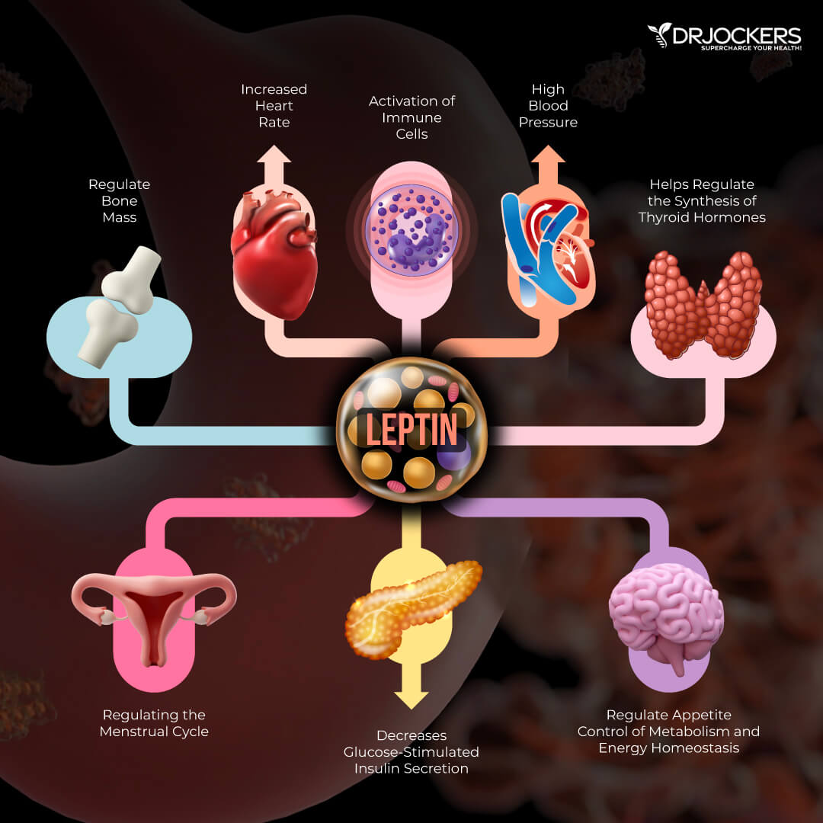

What is the ideal leptin level?

Ideally, leptin levels should be between 8 and 12 ng/mL, regardless of BMI or gender. This can be evaluated through a simple blood test taken first thing in the morning, while fasting.

What is the problem with low leptin?

Humans can experience significant problems when leptin levels get too low. Not only does that signal to the brain that energy stores are low, which can trigger increased appetite, it also signals to the brain that the body is essentially starving (ie. “we have no fat stores so let’s save everything”). This can cause a cascade of metabolic and hormonal problems. This is less common than high leptin (ie. leptin resistance) but will often present in patients who are: very highly stressed, do frequent low-carb or low-calorie diets, frequent fasting, or have intense workout routines. It is also often present in people with chronically high anxiety, and low leptin itself can make anxiety worse. Low leptin also causes low gonadotropic releasing hormone (GnRH), which in turn lowers luteinizing hormone (LH) from the pituitary gland. LH is crucial in both men and women to stimulate key sex hormones like testosterone and estrogen.

What are the symptoms of low leptin?

- Feeling stressed out often
- Low sex hormones – leading to infertility, low libido, abnormal menstrual cycles etc.
- Reduced energy levels/fatigue
- Increased appetite
- Rarely feeling satiated, frequent cravings (often for sweets)
- Low thyroid function (hypothyroidism), cold intolerance, low body temperature
- Abnormal blood sugar fluctuations
- Hyperactivity or restlessness
- Mood changes – depression, anxiety, irritability, brain fog, forgetfulness
- Immune dysregulation – increased susceptibility to infections and autoimmune diseases
- Osteopenia or osteoporosis
- Insomnia
- Fatigue, “burnout” feeling
- Weight management difficulties
- Feeling cold all the time, difficulty sweating

What is leptin resistance (ie. high leptin)?

A majority of Americans today experience leptin resistance: a phenomenon where the body produces plenty of leptin but there is a signal receptor problem in the brain so the hypothalamus doesn’t respond properly. This can lead to the brain thinking there is insufficient leptin. This will cause persistent hunger and extreme difficulty maintaining weight because the brain thinks it needs more fat stores, even though the person is likely overweight. As a result, the brain will prompt you to eat more to have build up energy stores, leading to further weight gain. Leptin resistance often presents even before insulin resistance and can be a crucial part of properly addressing metabolic disease. These problems mimic the hormonal problems that happen with low leptin.

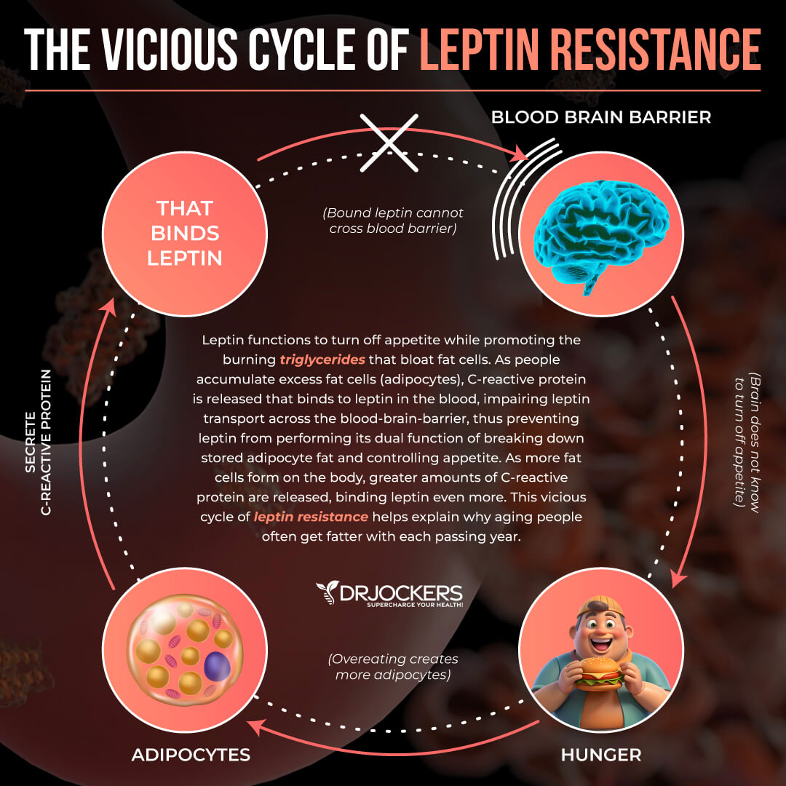

What are the symptoms of Leptin resistance?

- Cravings, especially carbohydrates
- Hunger even after meals
- Hunger in the evening time (night snacking)
- Weight gain
- Trouble losing weight – “I’ve tried every diet but nothing works”
- Trouble maintaining a stable weight – “If I have just one treat, I gain weight”
- Abdominal fat
- Low energy levels, fatigue
- Blood sugar imbalances
- High triglycerides
- High blood pressure
- Abnormal sweating
- Infertility
- PCOS or irregular menstrual cycles
- Low libido, low testosterone
- Low exercise tolerance, low endurance

What causes Leptin issues (low and high)?

By far the most significant factor in leptin issues is circadian rhythm dysfunction and bad light environments. Light coming in through the eyes is sent to a part of the brain called the superchiasmatic nucleus (SCN) that will kickstart a tightly regulated schedule of various hormones to be produced and released, including leptin. Artificial light is extremely high in blue light which, especially at night, is a signal for cortisol release. Cortisol is our “stress” hormone that is essential for energy and keeping us awake. It also stimulates gluconeogenesis (sugar production) in the liver for energy. The artificial light will simultaneously suppress melatonin production, which is not only important for sleep, but for cellular repair and detoxification. The spike in cortisol at night will prevent proper docking of leptin into the hypothalamus, thus propagating leptin signaling problems. Late nights – especially combined with late eating or elevated cortisol from artificial light – disrupt proper leptin signaling, which means your brain never gets the message about how much stored energy your body actually has.

Other factors that disrupt leptin signaling:
- Unhealthy diet – high in processed foods, seed oils, corn syrup, etc. while being low in essential nutrients from whole foods, especially animal proteins and fats
**Insulin will COMPETE with leptin for docking in the hypothalamus so it is important to not have huge spikes of glucose & insulin while trying to heal our leptin signaling**
- Poor sleep – even if you get 7 hours but are going to bed at 1am, you are missing the key repair zones for leptin to “dock” to the brain. It is crucial to be asleep by 10pm to maximize benefits.
- High stress
- Environmental toxins (mold toxicity, heavy metals, pesticides, chemicals, etc.)
- Chronic infections (Lyme disease, EBV, candida, gut infections, etc.)
- Immune system dysregulation (allergies, autoimmune disease, etc.)
- Chronic inflammation and pain
- Shame and negative thinking

How can we fix leptin signaling?

We basically have to reverse all the causes listed above. Please see my circadian rhythm guide and healthy eating guide for more details on lifestyle and dietary changes to improve leptin!

Other Helpful Resources:
- Sarah Kleiner Wellness
  - YouTube video: Leptin resistance is more common in winter
- Carrie B. Wellness
- Dr. Sara Pugh

